Sl. No. | Title | Page No.
i | Cover Page | i
ii | Certificate | ii
iii | Acknowledgments | iii
iv | Index of Contents | iv
v | About the Organization | 3
vi | Objectives of Internship | 6
vii | Learning Experiences | 21
viii | Learning Outcomes | 26
ix | Conclusion / Summary | 33
x | Attachments | 35

Index of Contents

ABSTRACT

This internship focused on Android App Development using Generative AI, where both theoretical knowledge and practical implementation were provided to develop modern mobile applications efficiently. The internship began with an introduction to Artificial Intelligence (AI), Generative AI, prompt engineering, autonomous agents, and the use of AI tools in software development to improve productivity and accelerate application development.
As part of the training, the learning platform MindMatrix was used to complete the “Android Development First Steps” program. The course included concepts related to AI, Salesforce, Agentforce, and hands-on activities through Trailhead modules such as Agentblazer Champion Intermediate. The internship also covered infrastructure setup and practical exposure to AI-powered development workflows.
The Android development phase focused on learning Kotlin programming, Android Studio, Jetpack Compose, UI design, state management, scrollable layouts, and modern Android application architecture. Daily Google Developer Code Labs and mini-projects were completed to gain hands-on experience in Android development concepts.
During the project phase, a real-time Android application named Nimma-Guru was developed. The application is a community mentorship platform that connects retired teachers, engineers, and skilled professionals (Gurus) with local students for free weekend learning sessions. The app allows mentors to create profiles, list their skills, set available timings, and help students discover nearby mentors based on subjects and interests. Features such as user login, mentor registration, student search, session scheduling, and community-based interaction were implemented in the application. Technologies such as Kotlin, Jetpack Compose, Firebase, frontend and backend integration were utilized during development.
This internship enhanced practical skills in Android app development, Generative AI usage, problem-solving, UI design, Firebase integration, and real-world project implementation while contributing to a socially impactful educational platform.

ABOUT THE ORGANIZATION

1.1 Overview :
The internship was carried out at MindMatrix, an organization focused on developing practical technology solutions using modern tools such as Artificial Intelligence, mobile application development, cloud platforms, and data-driven systems. The company provides students and young developers with an opportunity to work on real-time projects that address actual social and business challenges rather than only theoretical tasks.
One of the most valuable aspects of the organization was its learning-oriented environment. Team members were encouraged to explore new technologies, ask questions freely, and continuously improve their problem-solving abilities. Instead of simply assigning tasks, the mentors guided us through the complete development process starting from requirement analysis and planning to implementation, testing, and deployment.
The organization strongly emphasized innovation with social impact. Projects were designed not only to showcase technical skills but also to solve meaningful real-world problems. This was clearly reflected in the development of the Namma Vastra application, which aimed to support Karnataka’s handloom weavers by helping them connect directly with buyers through a digital platform.
During the internship, I was exposed to professional development practices such as writing Software Requirement Documents (SRDs), maintaining proper project structure, meeting weekly deadlines, and working collaboratively in a team environment. The experience helped me understand how software projects are handled in industry settings and how important communication, planning, and consistency are in successful project development.
The organization also promoted the use of modern technologies like Firebase, Android Studio, and Generative AI tools such as Google Gemini API, allowing interns to gain hands-on exposure to current industry trends. Overall, the internship at MindMatrix was not only a technical learning experience but also an opportunity to develop professional confidence, discipline, and practical thinking.

1.2 Mission :
MindMatrix aims to close the gap between engineering education and what industry actually expects from a fresh hire. The focus is not on making students memorize concepts, but on making them capable of sitting in a real development team and contributing from day one. This is achieved through hands-on project work, regular mentor-guided code reviews, and a structured evaluation process that reflects real-world standards.
1.3 Vision :
The long-term goal of MindMatrix is to ensure that engineering graduates particularly in Computer Science and related fields enter the workforce with practical Android development skills. The programme keeps its curriculum updated with what companies are currently using, which as of this batch includes Kotlin, Jetpack Compose, MVVM architecture, and Firebase.
1.4 Services and Programme Offerings:
- 16 week Android application development internship aligned with VTU guidelines.
- Structured project assignments focused on applications with real social relevance.
- Weekly code reviews and mentor walkthroughs.
- Guidance on preparing Software Requirements Documents (SRD).
- Training in MVVM architecture, Firebase Firestore, Google Gemini API, and Jetpack Compose.
- Evaluation based on Functionality, UI/UX Quality, Code Quality, and Documentation.
- Hands-on experience with Android Studio, Kotlin programming, and modern mobile app development tools.
- Daily coding exercises, Google Developer Code Labs, and mini-projects to strengthen practical knowledge.
- Exposure to Generative AI tools, prompt engineering, and AI-assisted software development workflows.
- Support in frontend-backend integration, Firebase authentication, database management, and real-time application deployment.

1.5 Organizational Structure:
The organizational structure of MindMatrix Industry Readiness Programme follows a systematic hierarchy for efficient programme management and intern coordination.
- Programme Director.
- Android Development Head and Project Mentors.
- Curriculum and Research Team.
- Evaluation and Quality Assurance Team.
- Project Assignment Team
- Administrative and Support Staff.

.

OBJECTIVES OF INTERNSHIP
2.1 Objective :
The primary objective of joining this internship was to bridge the gap between the theoretical knowledge gained through academic studies and the practical skills required in real-world software development. Although I had studied programming concepts and software development methodologies in college, I had limited experience in building a complete Android application independently. This internship provided an opportunity to gain hands-on experience in Android application development using modern technologies such as Kotlin, Jetpack Compose, Firebase, and MVVM architecture. Another important objective was to understand industry-level development workflows, improve problem-solving abilities, and develop the confidence to design, implement, test, and maintain a real-world mobile application. The internship also aimed to strengthen professional skills such as teamwork, project documentation, time management, and code quality through mentor guidance, project-based learning, and continuous evaluation.
2.2 Technical Objectives:
- To learn Kotlin properly not just syntax, but how to use it effectively for Android development including things like data classes, extension functions, and coroutines.
- To get hands-on experience with Jetpack Compose, which I had only read about but never actually used to build UI screens.
- To understand how MVVM architecture works in practice how the View, View Model, and Repository layers each play a role and why this separation matters.
- To learn how to integrate Firebase Firestore and Firebase Auth into an Android app understanding how real-time cloud databases work and how phone OTP authentication replaces traditional login flows.
- To complete a full Android project from requirements and design, all the way through implementation and testing without stopping in the middle.

2.3 Professional Objectives:
- To understand how software projects are planned and documented in industry, specifically through writing a Software Requirements Document.
- To get used to receiving feedback on my code and learning to improve it based on review comments rather than treating the first version as final.
- To develop the discipline of working on a project consistently over several weeks with deadlines, rather than doing it all at the last minute.
- To improve my ability to document my work clearly so others can understand what I built and why I built it that way.

2.4 Project Goals: Nimma-Guru
- To build a functional Android application that connects retired teachers, engineers, and skilled professionals with local students through a community mentorship platform.
- To develop a Mentor Directory module using Firebase Firestore, allowing mentors to create profiles, list their skills, subjects, and available timings.
- To implement a Student Search feature that helps students discover suitable mentors based on subjects, interests, and learning needs.
- To design a simple, user-friendly, and accessible interface that can be easily used by both students and senior mentors.
- To integrate Firebase Authentication, Jetpack Compose, and MVVM architecture for secure login, modern UI development, and efficient application management

PROJECT OVERVIEW
3.1 Project Title – Nimma-Guru
Nimma-Guru is a community mentorship Android application developed as part of the MindMatrix VTU Internship Program. The application is designed to connect retired teachers, engineers, skilled professionals, and experienced community members with local students who require academic or skill-based guidance. The platform promotes community learning and knowledge sharing by creating a simple, accessible, and non-commercial digital mentorship system.
The application focuses on enabling retired professionals, referred to as “Gurus,” to register their profiles, list their skills and available timings, and volunteer for mentoring sessions conducted at local community centres. Students can search for mentors based on subjects, skills, and location, making educational support more accessible within local communities.

3.2 Problem Statement
Many retired professionals in villages and towns possess valuable knowledge and experience that could benefit students and young learners. However, there is currently no simple digital platform that effectively connects these experienced individuals with students seeking guidance at the community level.
Students in smaller towns and rural areas often lack access to affordable mentoring and quality after-school educational support. At the same time, retired professionals willing to contribute to society do not have an organized system to offer their knowledge. Existing educational platforms are mostly commercial, complex, or focused on online learning rather than local community interaction.
The absence of a user-friendly mentorship platform creates a gap between available knowledge resources and students who could benefit from them. Therefore, the Nimma-Guru application was developed to provide a simple, accessible, and community-oriented solution that encourages voluntary mentorship and promotes educational support within local communities.

3.3 Project Description
Nimma-Guru is an Android-based community mentorship application developed using Kotlin, Jetpack Compose, MVVM architecture, and Firebase technologies. The application allows retired teachers, engineers, doctors, and skilled professionals to create mentor profiles and connect with local students for free educational sessions and knowledge-sharing activities.
The application provides mentor registration features where Gurus can add their profile details, skills, subjects, availability, and location information. Students can search for mentors using subject filters and discover suitable mentors nearby. The application also includes features such as appreciation walls, class schedules, bilingual support, and elderly-friendly navigation to ensure accessibility for all users.
Firebase Firestore is used for real-time database management, while Firebase Authentication is implemented for secure login and user management. The user interface is developed using Jetpack Compose with a focus on simplicity, readability, and accessibility. The application follows MVVM architecture to maintain proper separation between UI components, business logic, and data handling.
The overall objective of the project is to create a socially impactful digital platform that supports knowledge sharing, community learning, and educational accessibility through modern Android application development technologies.

3.4 Project Goals
- To develop a functional Android application that connects retired professionals with students through a community mentorship platform.
- To implement mentor registration and student search functionalities using Firebase Firestore and modern Android development practices.
- To design a simple and user-friendly interface suitable for both students and elderly mentors with minimal technical knowledge.
- To integrate Firebase Authentication, Jetpack Compose, and MVVM architecture for secure, scalable, and efficient application development.
- To encourage community-based learning and knowledge sharing through a socially impactful digital platform.
3.5 Scope of the Project
The scope of the Nimma-Guru application includes the development of a community mentorship platform that supports mentor registration, student search, session scheduling, and appreciation features. The application focuses on local community interaction and educational support rather than commercial tutoring services.
The project includes features such as bilingual language support, Firebase-based real-time database management, profile management, and user-friendly navigation for elderly users. The application is designed specifically for Android devices and supports modern Android application architecture using Kotlin and Jetpack Compose.
The current version of the project does not include paid services, online video classes, or advanced AI-based mentor matching systems. Future enhancements may include AI-assisted recommendations, voice search, notifications, and analytics features.

3.6 Functional Requirements
- Mentor registration with profile details, skills, location, and availability.
- Student search functionality with subject and skill filters.
- Mentor profile viewing and profile editing features.
- Session scheduling and class calendar management.
- Appreciation wall for student feedback and thank-you notes.
- Real-time Firebase Firestore data synchronization.
- Firebase Authentication for secure user login and profile access.

3.7 Non-Functional Requirements
- The application should provide a simple and elderly-friendly user interface.
- Search results and profile loading should be fast and responsive.
- The application should support Android devices running Android 8.0 and above.
- Data should remain synchronized using Firebase Firestore real-time updates.
- Proper security measures should be implemented for authentication and user data protection.
- The application should maintain scalability and clean architecture using MVVM principles.

3.8 Features of the Application
- Mentor Profile Registration
- Guru Search with Skill Filters
- Community Session Scheduling
- Appreciation Wall and Feedback System
- Wall of Fame for Top Mentors
- Firebase Firestore Real-Time Sync
- Elderly-Friendly UI Design
- Kannada and English Language Support
- Firebase Authentication
- Responsive User Interface using Jetpack Compose

3.9 Impact Goals
The primary impact goal of Nimma-Guru is to improve educational accessibility by connecting local students with experienced community mentors at no cost. The application encourages knowledge sharing, strengthens community relationships, and provides retired professionals with an opportunity to contribute meaningfully to society.
The project also aims to support digital inclusion among elderly users by providing an easy-to-use mobile platform. Through community mentorship and volunteer-driven learning, Nimma-Guru promotes social development, intergenerational learning, and accessible education using technology.

SYSTEM DESIGN AND IMPLEMENTATION

4.1 System Architecture
The Nimma-Guru application follows the MVVM (Model–View–ViewModel) architecture pattern to ensure proper separation between the user interface, business logic, and data management layers. This architecture improves code maintainability, scalability, and reusability while simplifying debugging and future enhancements.
The application consists of three primary layers:
- View Layer: Developed using Jetpack Compose, responsible for displaying UI components and handling user interactions.
- ViewModel Layer: Handles business logic, manages application state, and communicates between the UI and repository layers.
- Repository/Data Layer: Manages data operations with Firebase Firestore and Firebase Authentication services.
Firebase Firestore is used as the real-time cloud database for storing mentor profiles, session details, and appreciation notes, while Firebase Authentication manages secure user login and authentication processes.

4.2 Application Workflow
The workflow of the Nimma-Guru application is designed to provide a simple and user-friendly mentorship experience for both mentors and students.
- Users register or log in using Firebase Authentication.
- Mentors create profiles by adding skills, availability, and location details.
- Student users search for mentors using subject and skill filters.
- Students view mentor profiles and upcoming session schedules.
- Mentors and students interact through scheduled learning sessions.
- Students can post appreciation messages on mentor profiles.
- All data updates are synchronized in real time using Firebase Firestore.
This workflow ensures smooth interaction between users while maintaining accessibility and simplicity throughout the application.
4.3 UI/UX Design Approach
The user interface of Nimma-Guru was designed with a strong focus on simplicity, accessibility, and usability. Since the application is intended for both students and elderly mentors, the UI design prioritizes easy navigation and readability.
Jetpack Compose was used to create responsive and modern UI screens with reusable composable components. Large text sizes, clear buttons, proper spacing, and minimal navigation complexity were implemented to improve accessibility for senior users.
The application also supports bilingual functionality in Kannada and English to ensure better usability across local communities. The UI design follows modern Android design principles while maintaining a clean and intuitive layout.

4.4 Database Design using Firebase Firestore
Firebase Firestore was used as the backend database for storing and managing application data in real time. Firestore provides a NoSQL cloud-based database structure that supports scalability, real-time synchronization, and offline caching.
The major Firestore collections used in the project include:
- Mentors Collection: Stores mentor profile information such as name, skills, location, availability, and profile images.
- Sessions Collection: Stores details of upcoming mentorship sessions including timing and location.
- Appreciation Collection: Stores thank-you notes and feedback submitted by students.
- User Collection: Maintains authenticated user information and profile details.
Firestore real-time updates allow users to view newly added mentor information and session updates instantly without refreshing the application manually.

4.5 Authentication System
Firebase Authentication was implemented to provide secure user login and account management within the application. Authentication ensures that only authorized users can access profile management, session scheduling, and appreciation features.
The system supports user authentication through mobile number verification and OTP-based login mechanisms. This approach simplifies the login process while maintaining security and accessibility for users who may not be comfortable using traditional password systems.
Authenticated users can securely manage their mentor profiles, view sessions, and participate in mentorship activities within the application.

4.6 Frontend Implementation using Jetpack Compose
Jetpack Compose was used for developing the frontend user interface of the Nimma-Guru application. Compose simplifies Android UI development by allowing developers to create UI components declaratively using Kotlin code.
Several composable screens were developed, including:
- Login and Registration Screens
- Mentor Profile Screens
- Student Search Screens
- Session Calendar Screens
- Appreciation Wall Screens
- Home Dashboard and Wall of Fame Screens
State management techniques were implemented to update UI components dynamically based on user interactions and Firestore data updates. Compose also improved UI consistency and reduced the amount of boilerplate code required during development.

4.7 Backend Integration
Backend integration in Nimma-Guru was implemented using Firebase services to manage authentication, real-time database operations, and cloud data storage.
The repository layer handled communication between the application and Firebase Firestore. CRUD operations such as creating mentor profiles, updating schedules, retrieving mentor lists, and posting appreciation notes were implemented efficiently using Firebase APIs.
The integration process ensured seamless synchronization between frontend UI components and backend data operations while maintaining smooth application performance.

4.8 API and Firebase Integration
The project primarily utilized Firebase services for backend functionality and real-time data management. Firebase Firestore was integrated for storing mentor information and session details, while Firebase Authentication was used for secure user access management.
Firebase Storage was used for handling mentor profile images and media uploads. The application also leveraged Firestore offline persistence to ensure that previously loaded mentor information remained accessible during poor internet connectivity.
The integration of Firebase services simplified backend management and enabled efficient cloud-based application functionality.

4.9 Testing and Debugging
Testing and debugging were important phases of the project development process. Various testing methods were used to ensure application functionality, usability, and performance.
The following activities were performed during testing:
- Functional testing of mentor registration and search features.
- Authentication testing for OTP login validation.
- UI testing to verify responsiveness and accessibility.
- Database testing for Firestore synchronization and data retrieval.
- Error handling and debugging for crashes and runtime issues.
- Device compatibility testing on multiple Android versions.
- Android Studio Logcat, debugging tools, and emulator testing were extensively used to identify and resolve application issues. Continuous testing improved
Android Studio Logcat, debugging tools, and emulator testing were extensively used to identify and resolve application issues. Continuous testing improved application stability, performance, and user experience throughout the development process.

4.10 Application Screens / Snapshots

  - Sign in Screen
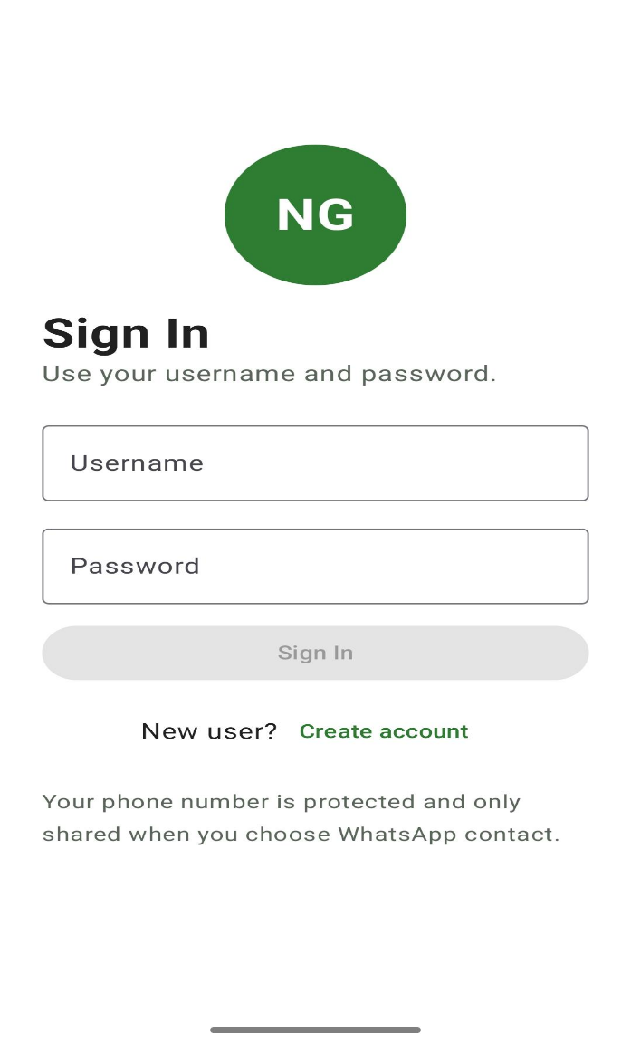

2. Create Account Screen
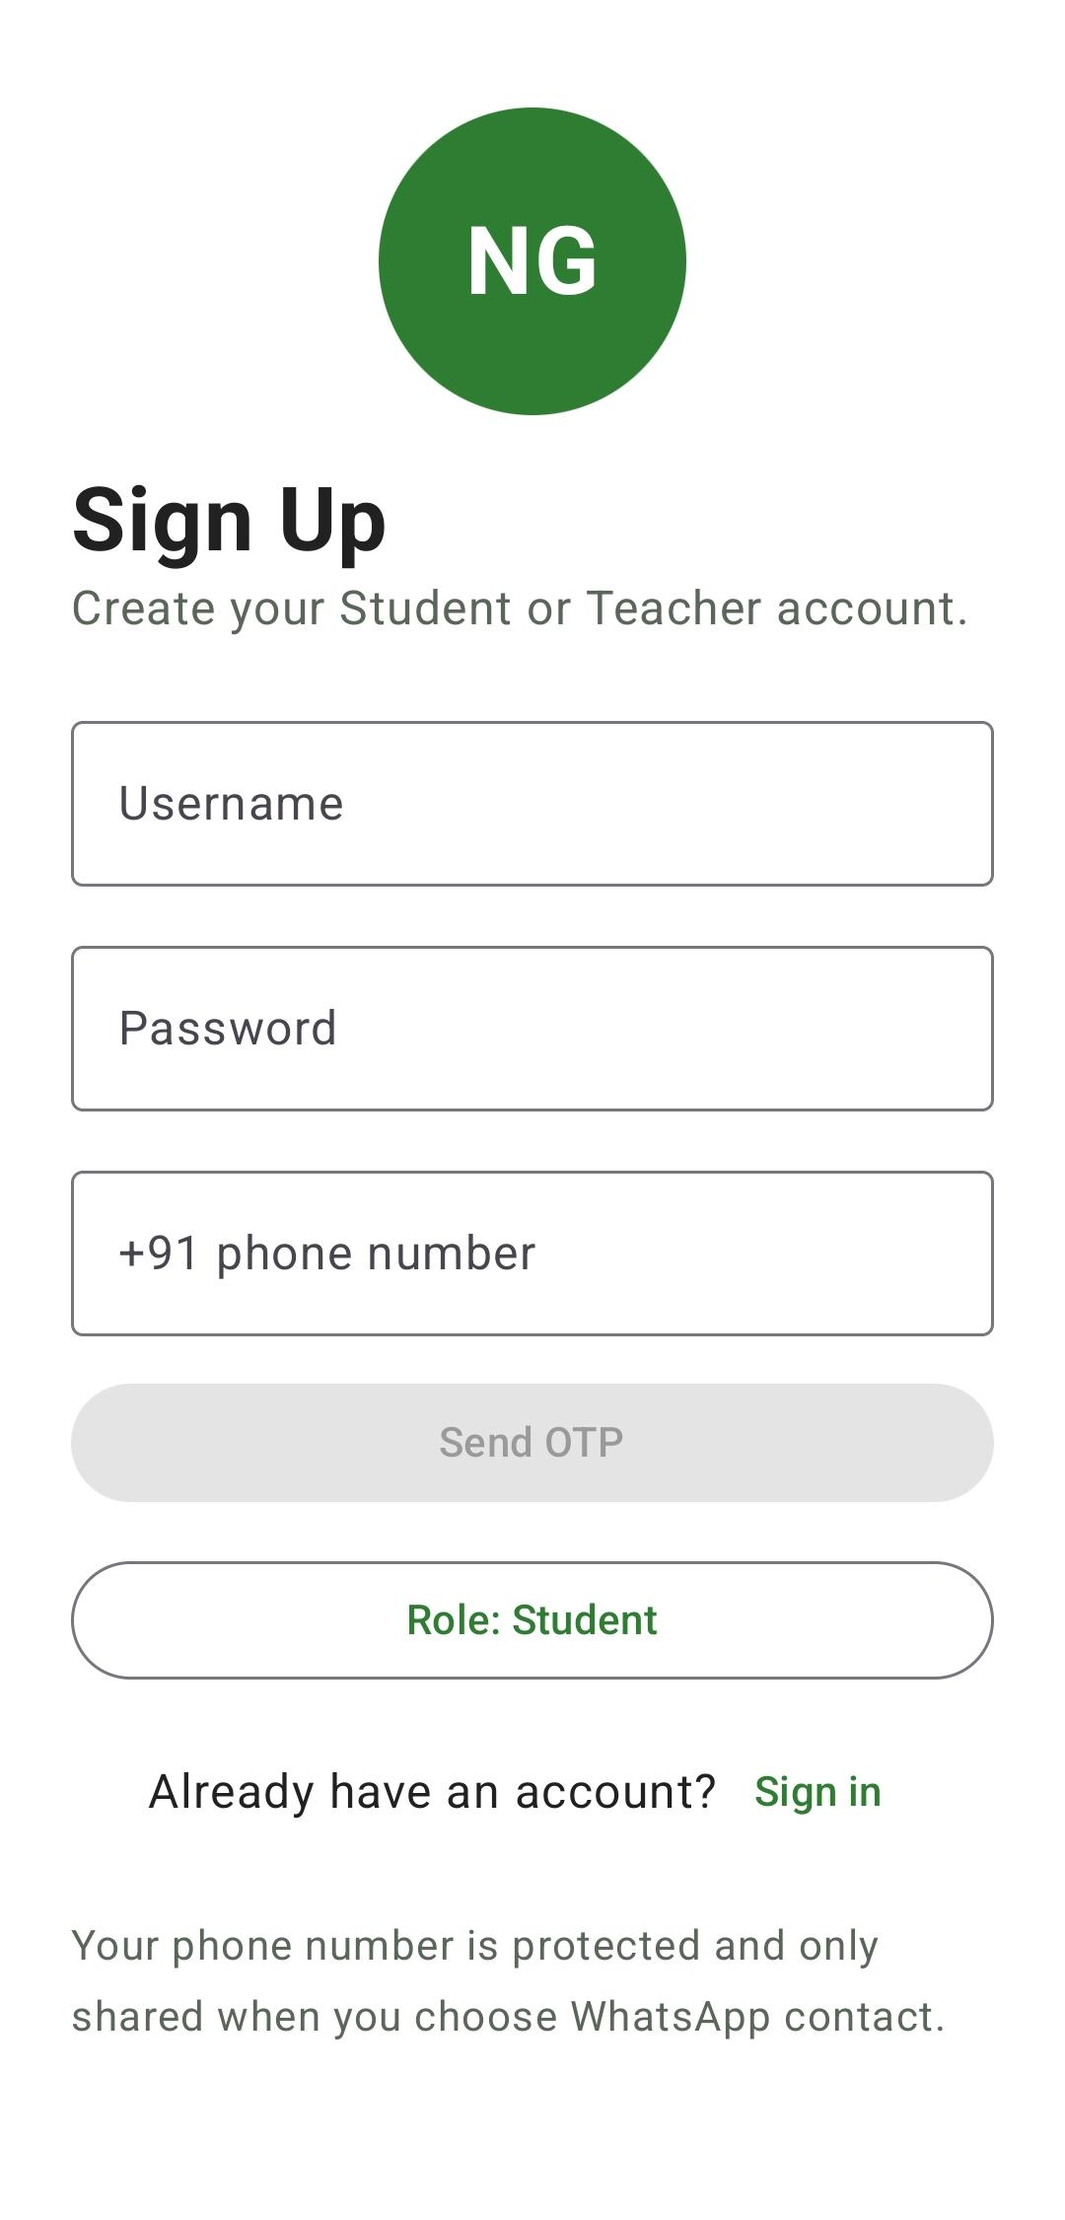
3. Dashboard Screen
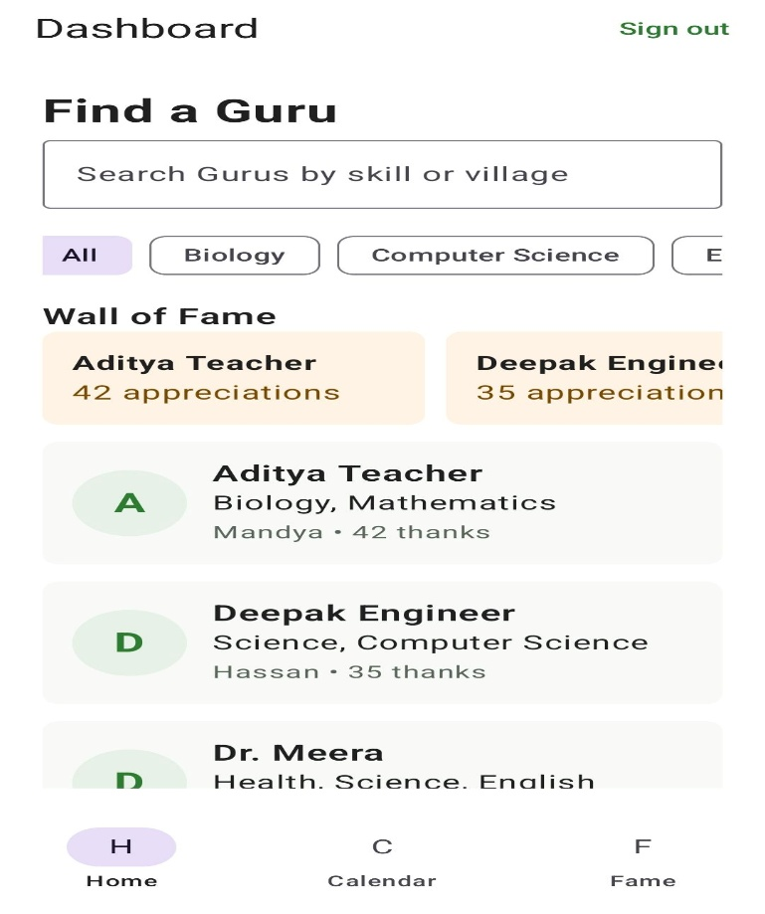
4. Guru Profile Screen
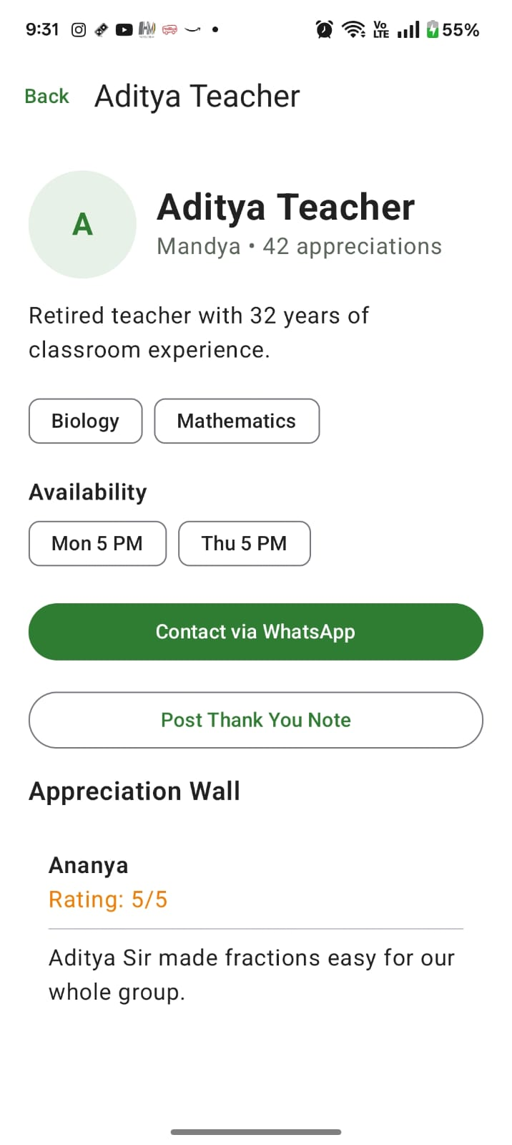
5. Calendar Screen
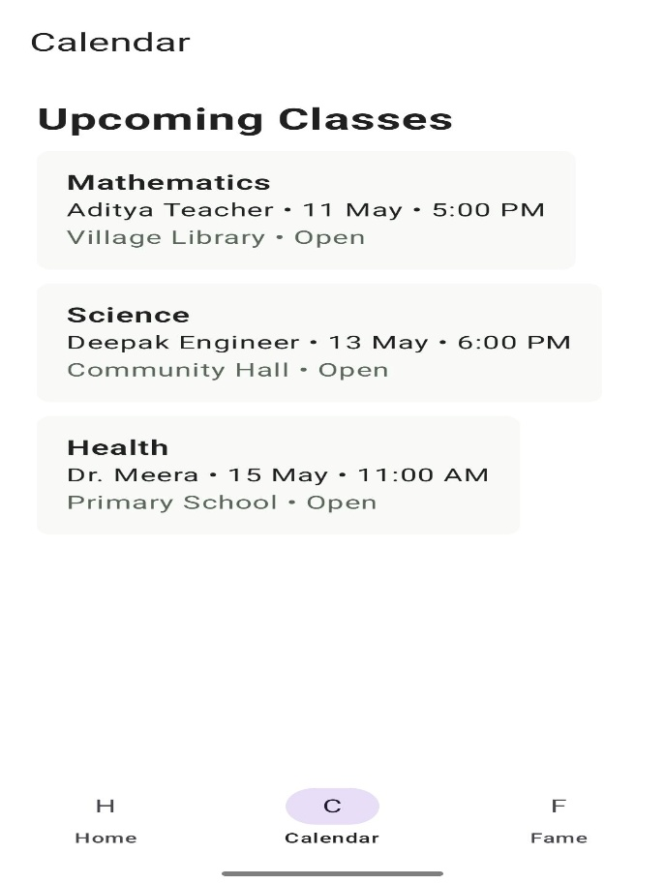
6. Wall of Fame Screen
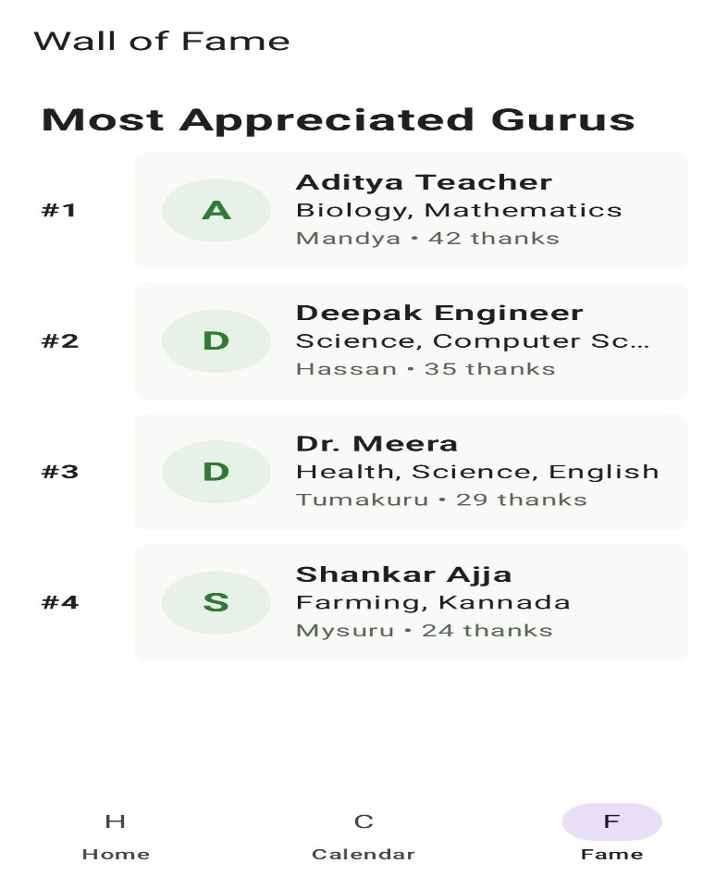
7 . Thankyou Note Screen
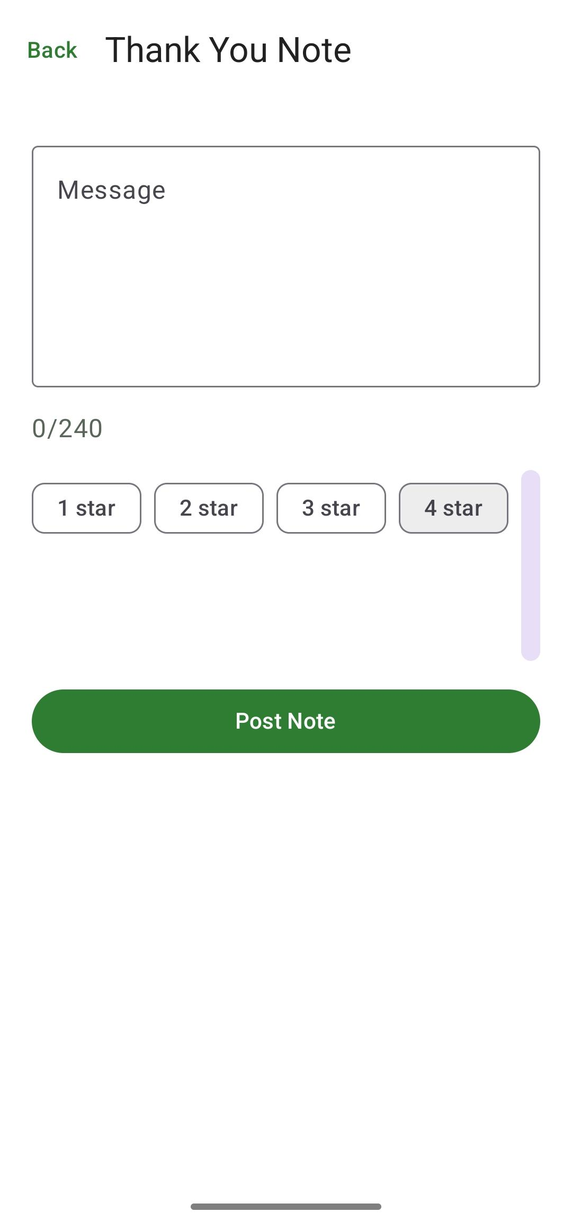

- FireBase Database
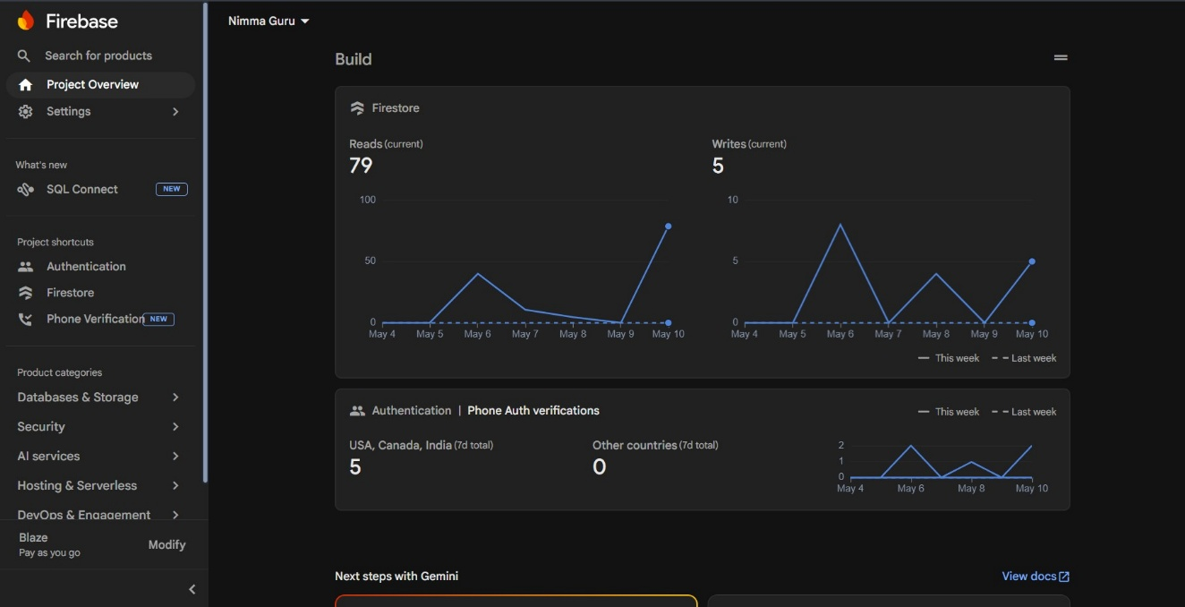

LEARNING EXPERIENCES

This internship proved to be highly valuable because it provided practical exposure beyond theoretical learning. Rather than simply following instructions, I was encouraged to independently analyze problems, explore solutions, and overcome technical challenges during the development process. There were several situations where implementation attempts did not work as expected, requiring repeated debugging, redesign, and problem-solving. This continuous cycle of experimentation, learning, and improvement helped me develop stronger technical skills, adaptability, and confidence in real-world software development practices—an experience that traditional classroom learning alone cannot fully provide.

Month | Week | Task Performed
Month 1 | Week 1 | Internship orientation, introduction to Artificial Intelligence, Generative AI concepts, and overview of Android application development.
 | Week 2 | Completed Agentblazer Champion 2026 learning modules and activities through Trailhead platform as part of AI and Salesforce learning.
 | Week 3 | Completed Google Skills Boost and "Android App Development: First Steps" programme through MindMatrix learning platform.
 | Week 4 | Learned Kotlin basics, Android Studio setup, Jetpack Compose fundamentals, and Android development workflow.
Month 2 | Week 5 | Practiced Android UI development using Jetpack Compose, Navigation Components, state management, and Google Developer Code Labs.
 | Week 6 | Studied MVVM architecture, Firebase Firestore, Firebase Authentication, and backend integration concepts for Android applications.
 | Week 7 | Worked on mini-projects and hands-on Android activities to improve practical development and debugging skills.
 | Week 8 | Prepared Software Requirements Document (SRD), identified project scope, functional requirements, and non-functional requirements for Nimma-Guru.
Month 3 | Week 9 | Planned system architecture using MVVM pattern and designed UI wireframes for mentor registration, search, and profile management screens.
 | Week 10 | Set up Nimma-Guru Android project using Kotlin, Jetpack Compose, MVVM architecture, Navigation Compose, and Firebase integration.
 | Week 11 | Developed mentor registration, Firebase Authentication login system, and mentor profile management using Firebase Firestore.
 | Week 12 | Built Student Search module with subject and skill filtering features and implemented Appreciation Wall functionality.
Month 4 | Week 13 | Developed session scheduling features, bilingual language support, and elderly-friendly user interface improvements.
 | Week 14 | Integrated all modules including mentor profiles, search functionality, session scheduling, and Firebase backend services.
 | Week 15 | Performed testing of all application modules including authentication, mentor search, Firestore synchronization, bilingual support, and UI responsiveness.
 | Week 16 | Fixed bugs, optimized application performance, completed project documentation, added application screenshots, and prepared the final internship report for Nimma-Guru.

5.1 Things That Were Harder Than Expected
One of the biggest challenges during the internship was understanding and implementing MVVM architecture properly in the Nimma-Guru project. Although the concept seemed simple in theory, applying it in a real Android application was initially confusing. I often struggled to decide where certain logic should be placed whether inside the UI layer, ViewModel, or repository layer. Through repeated practice, mentor feedback, and revisiting Android documentation, I gradually understood the importance of proper separation of concerns and clean architecture.
Firebase Firestore integration was another area that required more effort than I initially expected. Understanding real-time database synchronization, handling data retrieval, and structuring Firestore collections for mentor profiles, sessions, and appreciation notes involved a lot of experimentation and debugging. Managing asynchronous operations and ensuring smooth data updates between the frontend and backend also became an important learning experience during development.
Navigation between multiple screens using Navigation Compose also presented several challenges. Passing data between screens, managing navigation states, and handling back-stack behavior required careful implementation. In the beginning, small mistakes in navigation logic frequently caused application crashes or incorrect screen behavior. Referring to official Android documentation and testing different approaches helped me improve my understanding of modern Android navigation systems.
Another difficulty was designing an elderly-friendly user interface for the Nimma-Guru application. Since the application targets retired mentors who may not be highly familiar with smartphones, the UI needed to remain simple, readable, and easy to navigate. Balancing functionality with simplicity required multiple UI improvements, layout adjustments, and usability considerations during the development process.

5.2 Things That Went Better Than Expected
One of the most positive experiences during the internship was learning Jetpack Compose for UI development. Initially, Compose felt unfamiliar because its structure and development style were very different from traditional Android XML-based UI development. However, after consistent practice and implementation, building UI screens became faster, more organized, and more enjoyable. I particularly appreciated how UI updates could be visualized immediately, which made the development process more interactive and efficient.
Another aspect that exceeded my expectations was the mentor review and feedback process. At first, I was nervous about code reviews because I assumed the focus would mainly be on identifying mistakes. Instead, the reviews became one of the most valuable learning experiences during the internship. Mentors provided constructive suggestions, explained best practices patiently, and helped me understand how to improve code readability, maintainability, and application structure rather than simply correcting errors.
My debugging and problem-solving skills also improved significantly during the internship. In the beginning, even small errors felt difficult to identify and fix. Over time, I learned how to analyze Logcat messages, isolate problems step by step, and test features systematically instead of making random code changes. This improved my confidence in handling technical challenges independently.
Working with Firebase technologies turned out to be more manageable and rewarding than I initially expected. Successfully integrating Firebase Authentication and Firestore into the Nimma-Guru application and seeing real-time updates function correctly gave me practical confidence in working with backend-connected Android applications. It also helped me understand how cloud-based mobile applications operate in real-world environments.
Looking back at the internship, many concepts that initially seemed difficult gradually became comfortable through continuous practice, experimentation, and mentor guidance. The combination of hands-on implementation, regular feedback, and project-based learning significantly improved both my technical knowledge and confidence in Android application development.

5.3 Professional Takeaways
- Preparing a Software Requirements Document (SRD) before starting development helped me clearly understand the project requirements and organize the workflow systematically.
- Weekly targets and project deadlines improved my time management skills and helped me maintain consistent progress throughout the internship.
- I learned that professional software development is not only about making features work correctly, but also about writing clean, readable, and maintainable code.
- Working on the Nimma-Guru project taught me the importance of proper planning and requirement analysis before beginning implementation.
- I understood the importance of user experience in mobile application development, especially while designing interfaces for elderly mentors and local community users.
- Debugging became one of the most valuable learning experiences, helping me improve patience, analytical thinking, and problem-solving abilities.
- I realized the importance of proper documentation in software development for tracking progress, explaining features, and maintaining project clarity.
- Continuous mentor feedback and code reviews helped me improve coding standards, application structure, and professional development practices.
- The internship strengthened my confidence in independently building Android applications using Kotlin, Jetpack Compose, Firebase, and MVVM architecture.
- Overall, the internship provided practical industry exposure and helped me transition from theoretical learning to real-world software development experience.

LEARNING OUTCOMES

By the end of this internship, I genuinely felt that I had learned far more than I initially expected. The experience was not limited to completing assigned tasks or learning a few new technologies it provided a deeper understanding of how real-world software projects are planned, developed, tested, and improved. The internship helped me move beyond theoretical academic learning and gave me practical exposure to Android application development using modern technologies and industry-level workflows.
One of the most valuable outcomes of the internship was gaining hands-on experience in Android application development through the Nimma-Guru project. Before starting the internship, my understanding of Android development was mostly limited to theoretical concepts and small academic exercises. During the internship, I learned how a complete Android application is developed from the initial idea and requirements stage all the way to implementation, testing, debugging, and documentation. Working on a real project gave me confidence in my ability to independently develop functional mobile applications.
Developing the Nimma-Guru application also improved my understanding of how different components of an Android application interact with each other. I learned how frontend user interfaces communicate with backend services, how application state is managed, and how data flows between different layers of the project using MVVM architecture. Seeing the application gradually evolve from basic screens into a working mentorship platform was one of the most satisfying parts of the internship experience.
Another major learning outcome was gaining practical knowledge of Firebase services. Initially, Firebase concepts such as Firestore, Authentication, and cloud data synchronization seemed difficult because I had never worked with real-time databases before. However, through continuous implementation and testing, I learned how Firebase Authentication handles secure user login and registration and how Firestore stores and synchronizes application data in real time.
Working with Firebase helped me understand how modern mobile applications manage backend services efficiently without requiring complex server-side development. Implementing mentor profile storage, student search data, appreciation notes, and session scheduling using Firestore gave me practical exposure to cloud-connected Android applications. Successfully integrating these features into the Nimma-Guru application significantly improved my confidence in backend integration and real-time application development.
The internship also provided valuable experience in user interface design and frontend development using Jetpack Compose. At the beginning, Compose development felt challenging because its declarative approach was very different from the traditional Android UI systems I had seen previously. Over time, however, I became comfortable building responsive and interactive screens using composable functions and state management techniques.
Working on UI development for the Nimma-Guru project also taught me the importance of user-centered design. Since the application targets retired mentors and local community users, I had to focus on readability, navigation simplicity, and accessibility while designing the screens. This experience helped me understand that a technically strong application also needs a simple and comfortable user experience for people to use it effectively.
Another important learning outcome was the improvement in my debugging and problem-solving abilities. Throughout the development process, I encountered many technical issues related to Firebase integration, navigation management, UI rendering, and state updates. Initially, these problems felt frustrating because I was unfamiliar with Android Studio debugging tools and systematic troubleshooting methods.
As the internship progressed, I gradually learned how to analyze errors patiently, interpret Logcat messages, isolate issues step by step, and test features carefully instead of making random changes to the code. This improvement in debugging skills not only helped me complete the project successfully but also increased my confidence in handling technical challenges independently.
The internship also helped me improve several professional and communication skills. Working on a multi-week project taught me the importance of time management, consistency, and structured planning. Meeting weekly goals and deadlines encouraged me to maintain regular progress throughout the project instead of delaying work until the final stages.
Another valuable professional learning experience was understanding the importance of documentation and requirement analysis in software development. Preparing the Software Requirements Document (SRD) before starting implementation helped me clearly understand the project scope, system requirements, and module structure. This made the development process more organized and reduced confusion during implementation.
Code reviews and mentor feedback also became an important part of my professional growth during the internship. Initially, I focused mainly on making the application work correctly. Through continuous feedback, I learned that professional software development also requires writing clean, readable, maintainable, and well-structured code that other developers can easily understand and improve in the future.
The internship additionally improved my communication and teamwork abilities. I learned how to discuss project ideas, explain technical implementation decisions, and accept constructive feedback positively. These experiences helped me become more comfortable collaborating within a professional development environment.
One aspect that made this internship especially meaningful was the social purpose behind the Nimma-Guru project. The application was not developed only as a technical assignment it was designed to help connect retired professionals with students and promote community-based learning. Working on a project with social impact made the entire development process more motivating and rewarding because the application was intended to solve a real community problem rather than simply demonstrate technical features.
Overall, the internship provided valuable industry exposure and significantly improved both my technical and professional capabilities. It strengthened my confidence in Android application development, improved my problem-solving ability, and gave me practical experience with modern technologies such as Kotlin, Jetpack Compose, Firebase Firestore, Firebase Authentication, and MVVM architecture. Most importantly, the internship increased my interest in software development and motivated me to continue learning and improving as an Android developer.

6.1 Technical Skills Gained
- Kotlin Programming: I gained strong practical understanding of Kotlin programming for Android development, including concepts such as data classes, extension functions, coroutines, and state management.
- Jetpack Compose: I learned how to build modern Android user interfaces using Jetpack Compose, including forms, navigation systems, lists, cards, and responsive UI components with reactive state updates.
- MVVM Architecture: I understood how to structure Android applications using MVVM architecture to maintain proper separation between UI, business logic, and data management layers.
- Firebase Firestore: I learned how to design and manage a real-time cloud database using Firebase Firestore for mentor profiles, sessions, appreciation notes, and application data synchronization.
- Firebase Authentication: I gained experience implementing secure user authentication systems using Firebase Authentication and OTP-based login functionality.
- StateFlow and Coroutines: I learned how to manage asynchronous operations and reactive UI state updates efficiently using Kotlin Coroutines and StateFlow.
- Navigation Compose: I developed the ability to implement navigation graphs, manage multiple application screens, and pass data between screens using Navigation Compose.
- UI/UX Design: I improved my understanding of responsive and user-friendly mobile interface design, especially for elderly and non-technical users.
- Software Documentation: I learned how to prepare Software Requirements Documents (SRD), project documentation, functional requirements, and implementation details systematically.
- Testing and Debugging: I improved my debugging skills by learning how to analyze runtime errors, handle crashes, identify issues systematically, and test application modules effectively.

6.2 Professional Skills Gained
- Learned how to work on a project based on a structured requirements document rather than developing features without planning.
- Improved my ability to accept and implement mentor feedback during code reviews professionally.
- Developed better time management and task planning skills while working on a multi-week project with deadlines.
- Learned the importance of writing clean, maintainable, and readable code for long-term project scalability.
- Improved communication skills through project discussions, technical explanations, and documentation preparation.
- Understood the importance of consistency, discipline, and regular progress during software development projects.
- Gained confidence in independently solving technical problems and implementing Android application features.
- Learned how professional software development workflows operate, including planning, implementation, debugging, testing, and reporting.

6.3 What the Nimma-Guru Project Delivered

- A fully functional Android application that connects retired teachers, engineers, and skilled professionals with students through a community mentorship platform.
- Mentor registration and profile management system with skills, availability, subject expertise, and location details using Firebase Firestore.
- Student search functionality with subject and skill filtering for discovering suitable mentors within the local community.
- Session scheduling and calendar management features for organizing mentorship activities and learning sessions.
- Appreciation Wall feature allowing students to post thank-you notes and feedback for mentors.
- Firebase Authentication-based secure login system with user profile management.
- Bilingual user interface supporting both Kannada and English language accessibility.
- Elderly-friendly user interface developed using Jetpack Compose with simple navigation and readable layouts.
- Real-time database synchronization using Firebase Firestore for seamless frontend-backend integration.
- A socially impactful Android application designed to encourage knowledge sharing, community learning, and accessible mentorship opportunities.

6.4 Skills Summary

Technical Skills | Professional Skills
Kotlin Programming | Technical Documentation Writing
Jetpack Compose UI Development | Time and Deadline Management
MVVM Architecture | Requirement Analysis and SRD Preparation
Firebase Firestore Integration | Structured Problem Solving
Firebase Authentication | Receiving and Applying Mentor Feedback
Navigation Compose | Clear Technical Communication
Android Studio Development | Independent Project Management
StateFlow and Kotlin Coroutines | Team Collaboration and Coordination
UI/UX Design for Mobile Applications | Debugging and Testing Discipline
Firebase Backend Integration | Consistent Learning and Self-Improvement

Conclusion

When I started this internship, I was uncertain about how much practical knowledge I would gain and how real-world software development actually takes place. Although I had studied programming concepts, software engineering principles, and application development basics through academics, I had never independently developed a complete Android application that solved a real community problem. This internship completely changed that experience for me.
Working on the Nimma-Guru project gave me the opportunity to apply theoretical knowledge in a practical environment and understand the complete software development lifecycle. Developing a community mentorship application that connects retired professionals with students provided a meaningful and socially impactful objective throughout the internship. Having a real-world purpose behind the project made the learning experience much more engaging and motivating.
The internship significantly improved my technical skills in Android application development. Through continuous implementation and project-based learning, I gained practical experience in Kotlin programming, Jetpack Compose, MVVM architecture, Firebase Firestore, Firebase Authentication, Navigation Compose, and modern Android development practices. More importantly, I developed a deeper understanding of how these technologies work together to create scalable, maintainable, and user-friendly mobile applications.
One of the most valuable aspects of the internship was learning through practical problem-solving rather than only theoretical study. During the development process, I encountered several technical challenges related to Firebase integration, navigation handling, state management, UI development, and debugging. Solving these problems gradually improved my analytical thinking, patience, and confidence in handling software development tasks independently.
The internship also taught me several important professional lessons beyond technical skills. Preparing a Software Requirements Document (SRD) before development helped me understand the importance of proper planning and requirement analysis. Regular mentor feedback and code reviews taught me that professional software development is not only about making features work correctly, but also about writing clean, organized, and maintainable code. Working consistently throughout the internship improved my time management skills and showed me the importance of discipline and continuous progress during long-term projects.
Another meaningful aspect of the internship was the social purpose behind the Nimma-Guru project. Developing an application designed to support students and encourage knowledge sharing through community mentorship helped me understand how technology can be used to create positive social impact. The experience made me think more carefully about user needs, accessibility, and how applications should be designed for real users rather than only focusing on technical implementation.
Overall, this internship provided valuable industry exposure and helped me grow both technically and professionally. It strengthened my confidence in Android application development, improved my problem-solving abilities, and gave me practical understanding of modern software development workflows. Most importantly, the internship motivated me to continue learning, improving my skills, and exploring future opportunities in Android and software development.

ATTACHMENTS

The following documents are attached as supporting material for this internship report:
- Internship Offer Letter from MindMatrix (CL Infotech Pvt. Ltd.).
- Internship Completion Certificate from MindMatrix.
- Software Requirements Document (SRD) for the Namma Vastra Project
- Screenshots of the Nimma Guru Android Application.

